# Automating Audit process using Gen AI

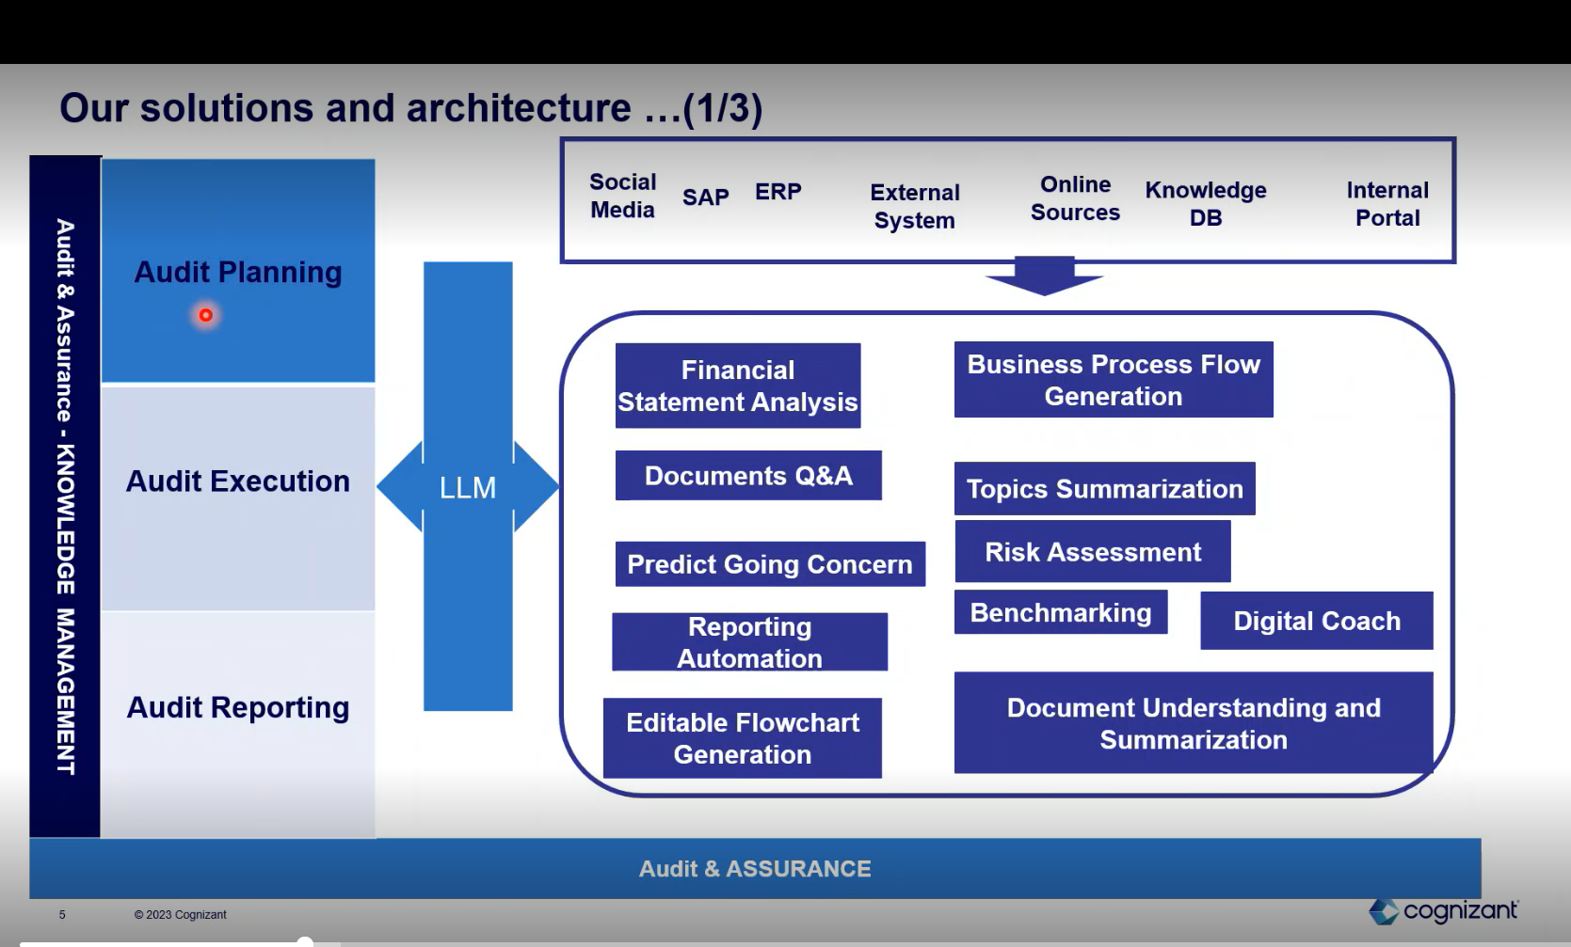

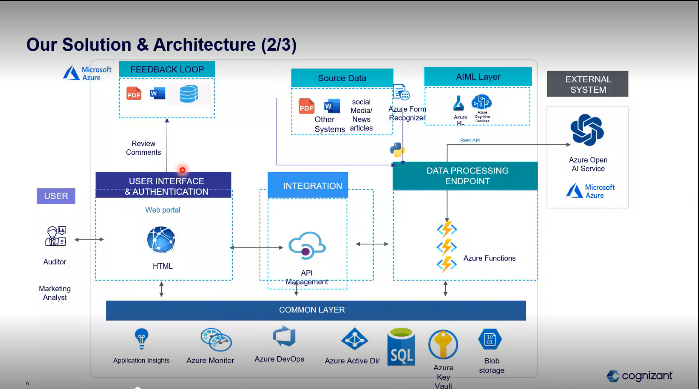

## Use Cases:

## Semantic Search:

Building a semantic search tool for auditors which would answer any questions related to PCAOB auditing standards accurately to the point.

Input: 639 pages PCAOB auditing standards PDF

Output: The solution will respond to user queries with formatted answer with examples, if applicable and citations to the page and paragraph numbers from PCAOB guidance.

## Digital Coach.

The solution should provide clear and accurate.

The solution should provide clear and accurate guidance on auditing standards, methodologies and best practice to assist auditors in performing their tasks effectively. It should enhance audit process by providing standardized procedures and templates. The information provided by the solution should be relevant and up to date based on the amendments or updates made by the respective regulators. It should be capable of offering real-time support.

Input: Input as pdf form PCAOB, FASB, AICPA, SEC regulations.

Output: The solution provides in Chatbot form.

## Business Process Narrative & Flow Diagram

General, populate and review flowcharts and narratives of processes based on information from walkthroughs, supplemented by accounting policies, client standard operating procedures, client flowcharts, etc. as appropriate.

Inputs – Call Transcript, Operational Guidelines.PDF format

Output – Business Process Flow Charts, Summary report of call transcript.

## Entity Understanding & Going Concern Analysis.

Generate, populate and review understanding the entity screens based on information from recent events, press releases, news laws and regulations, accounting policies, prior year documentation etc.

Input: The SEC filling documents in PDF format and external URLs:

Form 8k

Form 10k

Annual Proxy

External URLs news

Output – The solution provides the following output results:

Summary Report from the financial documents.

Summary Report from the financial external news source.

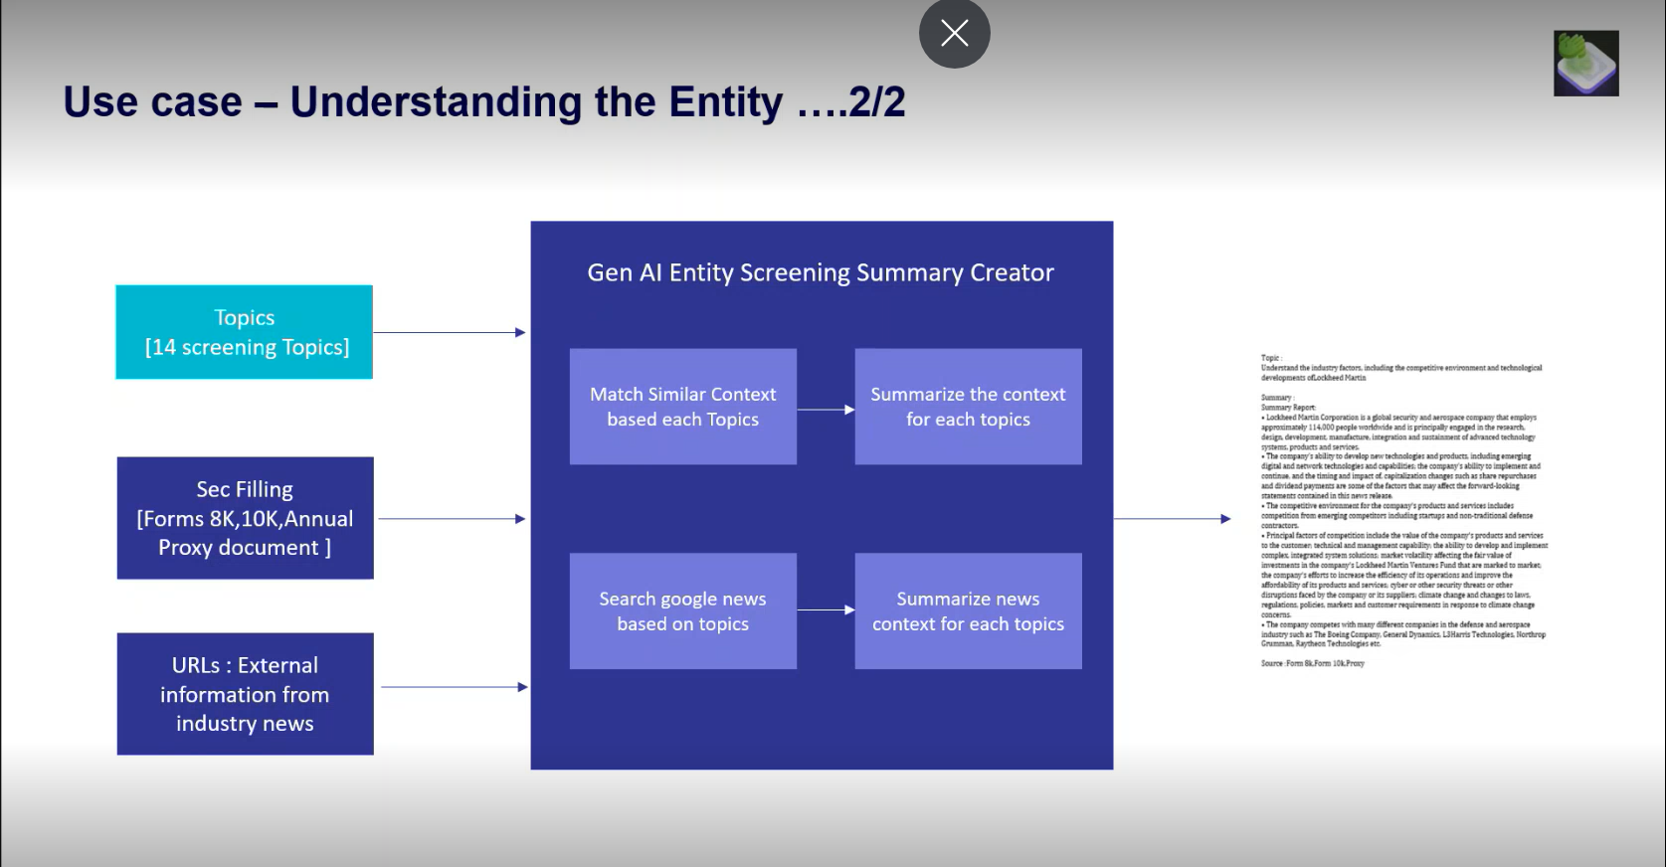

## Going Concern Analysis

Predict going concern issues based on client general ledger business model and industry factors scraping data from social media, publications and regulatory actions as well as comparing to peers.

Inputs: The SEC filling documents in PDF format and external URLS.

Output: Generated description summary in word format.

Sentiment analysis for going concern based on influential factors.

Predicting failure rate.

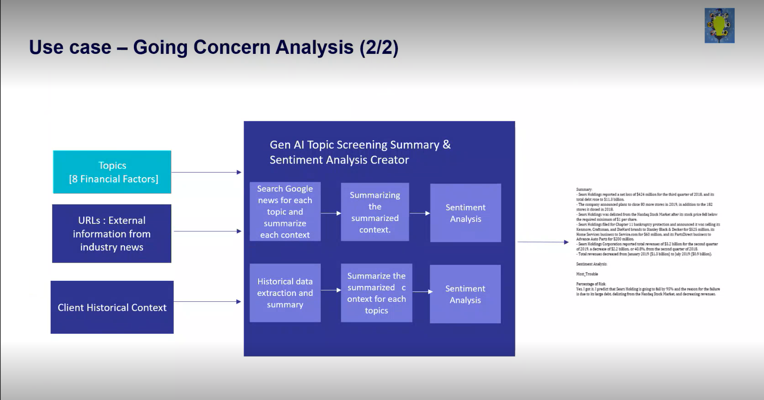

## Financial Statements Review - Lead Sheet, Testing Metrics & Planning Analytics.

Generate populate and review lead sheets and testing matrices using defined procedures from audit program guides and if possible, integrating specific detail from the sample selections.

Input; Trial Balance, Lead Sheet Template, Current and Prior year Financial Statements,

Substantive procedure Documents, Property, Plant and Equipment Documents.

Outputs- Multiple Lead sheets each for a Financial Statements captions

Testing Matrices for each account in the Financial Statement CAPTION.



